**Trams Back Office Installation for New Installs**

If installing Trams Back Office on new computer that does not already have Trams Back Office or ClientBase installed, use the instructionsbelow. Reminder: A TramsImplementation representative will be calling to assist with the installation process. You can contact the Implementation team by emailing [Trams.Implementation@sabre.com](mailto:Trams.Implementation@sabre.com).

**Step 1: Download the Program File.**After selecting the computer to install Trams Back Office on, download the Trams Products Installation setup.exe file into a folder on the computer. (If you will install Trams Back Office on more than one computer, we suggest that you save it to a shared folder that can be accessed from other computers on the network, so that you only need to download it once.) The file is linked below:

[Trams Products Installation File](http://static.trams.com/tramslibrary/Releaseandupdatefiles/Updates/40700/setup.exe)

**Step 2: Run** *setup.exe*. Browse to the folder that holds the setup.exe file. Double-click the file to launch the installation wizard. If you want to install only Trams Back Office, uncheck ClientBase. If your agency will use both products, leave them both checked.

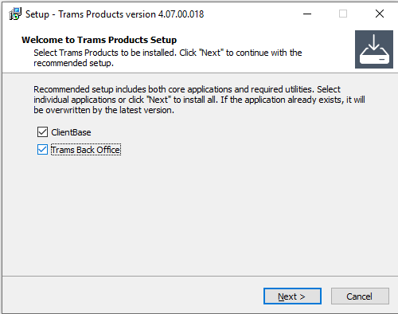

**Step 3. Click***Next*and*decide whether you want to install as a Server or a Workstation.* If Trams will only be used on one computer, choose Server. If you are installing for multiple users, one computer must be designated as the Server. The Server will house the database. All other computers will be set up as Workstations, which will connect to the Server over a network.

Workstation is selected by default. We will cover a Server Installation first, then cover Workstations at the end.

**To install a Server,** choose the Server radio button, then click Next.

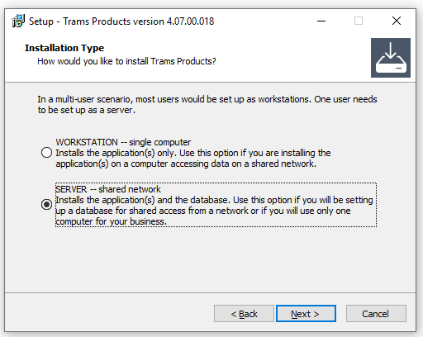

**Step 4.** Enter your InterBase Server Serial Number and Access Code. (You will have this in an email from Trams.) Then click Next.

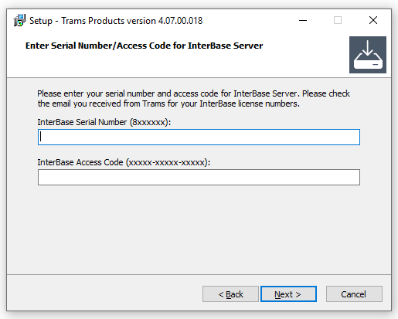

**Step 5.** Select the file location for your database to be installed. Leave the database name and path as the default, or change them if you have another preference. Click Next when satisfied with the name and location of the database.

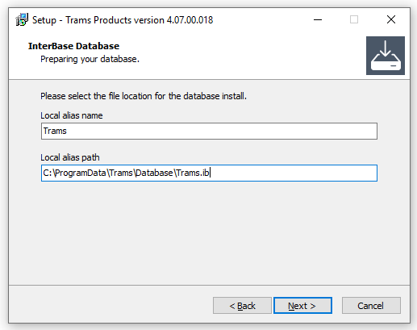

**Step 6.** Select your country. If not shown, choose the country whose currency and taxes best map to yours. Click Next when finished.

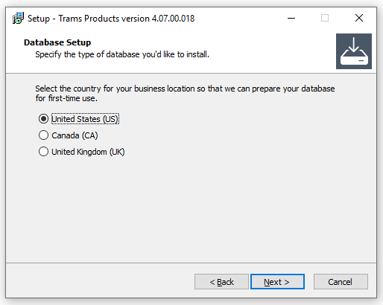

**Step 7.** Choose whether to add shortcuts to your desktop**.** If you’d like to add a shortcut on your desktop for Trams Back Office (and ClientBase, if you chose to install it), then leave the first box checked. If not, uncheck it. The second option, for a French version of ClientBase, is intended for ClientBase users with many French-speaking customers. Check that box if that describes your agency. Click Next when ready.

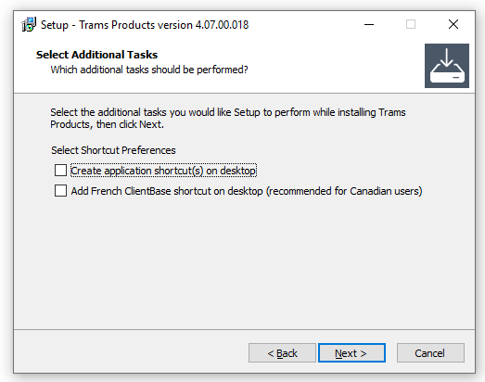

**Step 8. Ready to Install!** Review the options that you have selected. Click Back if you want to make changes. Otherwise, click *Install*. Trams Back Office (and ClientBase, if selected, will be installed in the default destination folder.

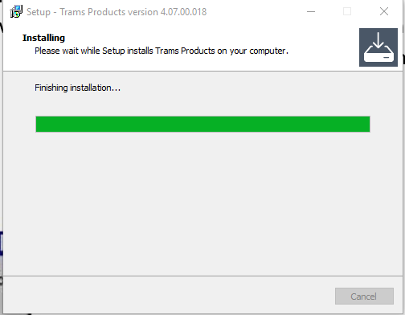

**After installation is complete, a blank database with the filename of Trams.ib is created.**

For Windows 7, Windows 8, Windows 10, Server 2008 (R2), or Server 2012 (R2), the default path to your database is: C:\ProgramData\Trams\Database\Trams.ib

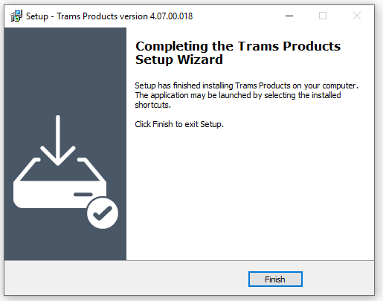

If you changed the database location in step 5, make a note of it. You’ll need it when you install any Workstations.

**Workstation Installation for multiple users**

**Step 1.** For each workstation, browse to the folder where the TramsBack Office installation file was saved, and launch setup.exe. Select Workstation, then click Next.

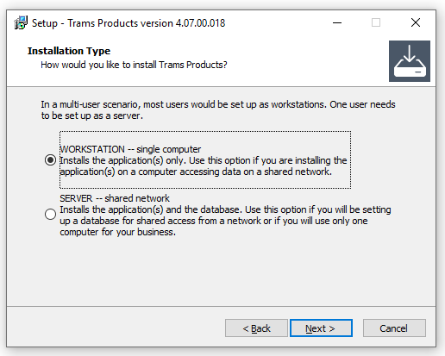

**Step 2.** Choose whether to add shortcuts to your desktop**.** If you’d like to add a shortcut on your desktop for Trams Back Office (and ClientBase, if you chose to install it), then leave the first box checked. If not, uncheck it. The second option, for a French version of ClientBase, is intended for ClientBase users with many French-speaking customers. Check that box if that describes your agency. Click Next when ready.



**Step 3. Ready to Install!** Review the options that you have selected. Click Back if you want to make changes. Otherwise, click *Install*. Trams Back Office (and ClientBase, if selected) will be installed in the default destination folder.

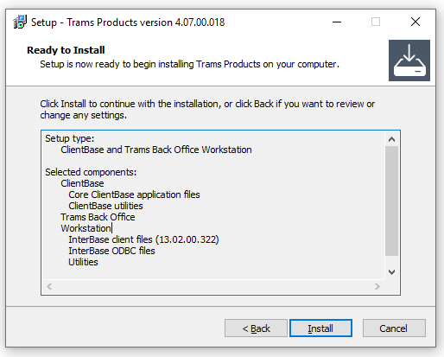



Step 4. Finished. Click the Finish button.

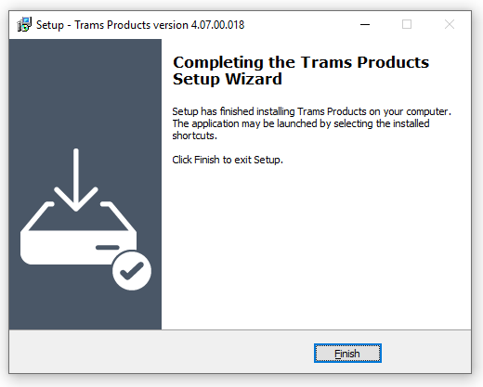

After each workstation has Trams *Back Office* installed, direct its Alias to the correct database file. To change the path to the database, go to **Start | All Programs| Trams Back Office | Alias Utility***.* Select the Trams Alias, click Modify, and update the path to point to the Trams*.ib database* located on the server, using the format required for remote connection via TCP/IP.

For Windows 7, 8.0, 8.1, or 10 and for Server 2008 (R2) or Server 2012 (R2), the default path is:

**ServerName:C:\ProgramData\Trams\Database\Trams.ib**

**Replace the default with your own server name and path, then click OK.**

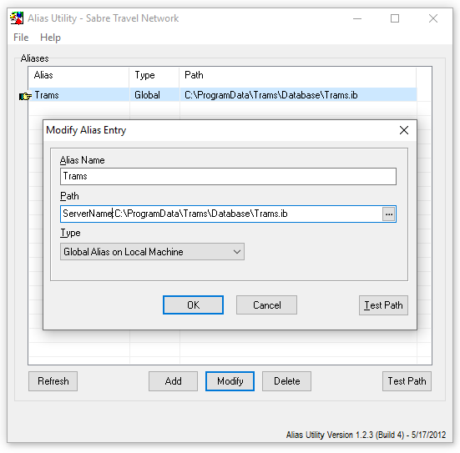

You can test to make sure the connection to the server is working by clicking the Test Path button and entering your username and password.

**Auto-Update Feature**

Trams Back Office will automatically install updates when they become available. Auto-update greatly streamlines installing updates on users' workstations and ensures fixes are being installed in a timely manner. Auto-update will only install updates that match the current major version (4.09.01 or 4.08.02, for example).

When Trams Back Office is launched, the auto-update feature checks to see if a newer version is available, then automatically downloads and installs the update on the users' workstation. The automatic update works for tramswin, download, ibbackup, and the ibbackuplib files. The earlier versions of the executables will be renamed by appending .old to the file name during the process, so they are available to roll back to an earlier version, if necessary.

Users can postpone the auto-install routine and will be reminded 24 hours later upon the next login attempt. **Note:** If a user does not have administrative rights, the auto-update routine won't be able to install the new versions. You can get around this by giving users read/write/delete access to the folder where Trams Back Office is installed.